# SDInterface SDWriter Module Design & Development

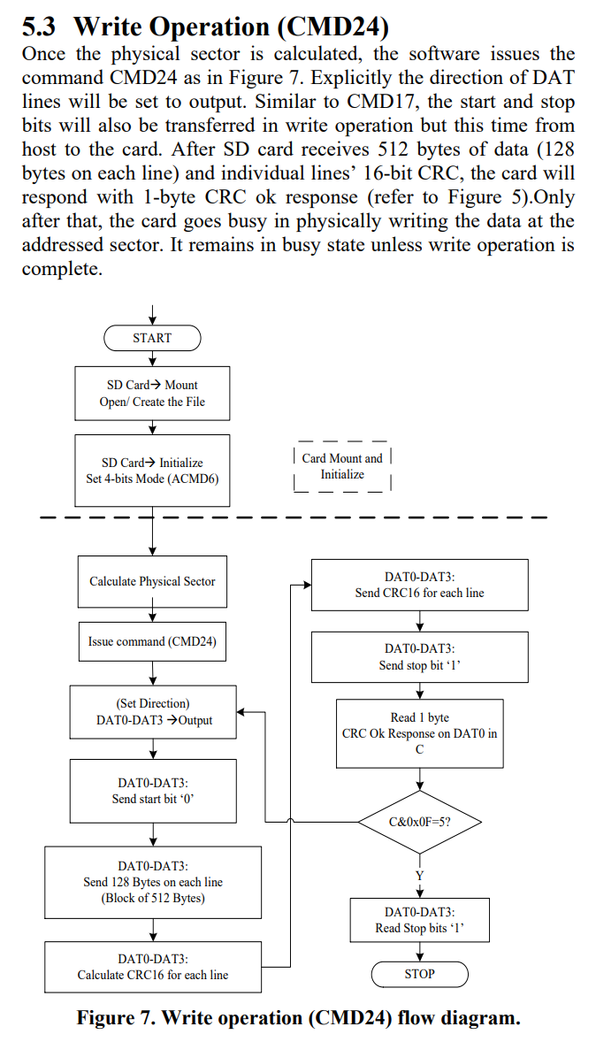The SDWriter module needs to closely follow the steps below to ensure a successful write to the SD card:

It should be noted that the initialisation sequence will have been completed and the SD card should already be in Transfer Mode as a result of prior RD operations executed as part of the host’s start-up sequence.

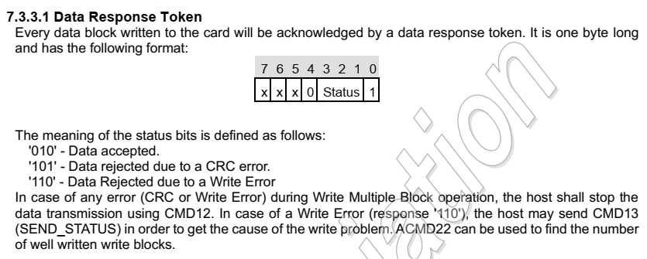

Above relates to the CRC OK byte that is transmitted by the SD card on successful receipt of a data block.

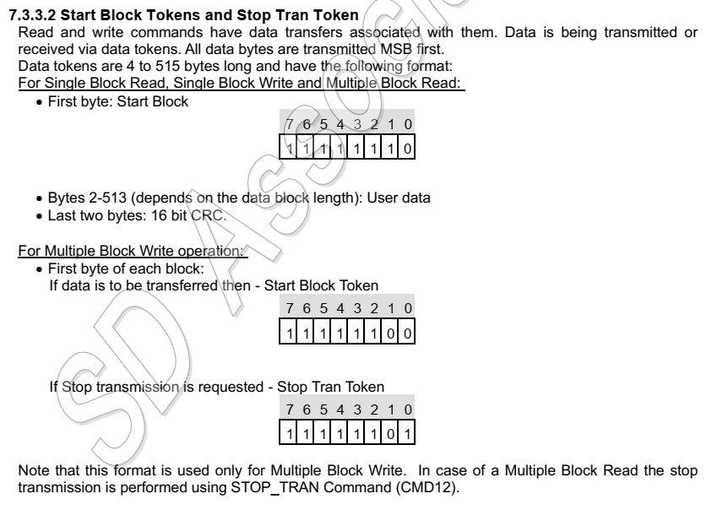

The above is important. The first byte sent MUST be the ‘START BLOCK’ byte – 0xFE, but looking at the timings on the next page, it needn’t be a whole byte and we can probably just get away with transmitting a nybble (bits 3-0).

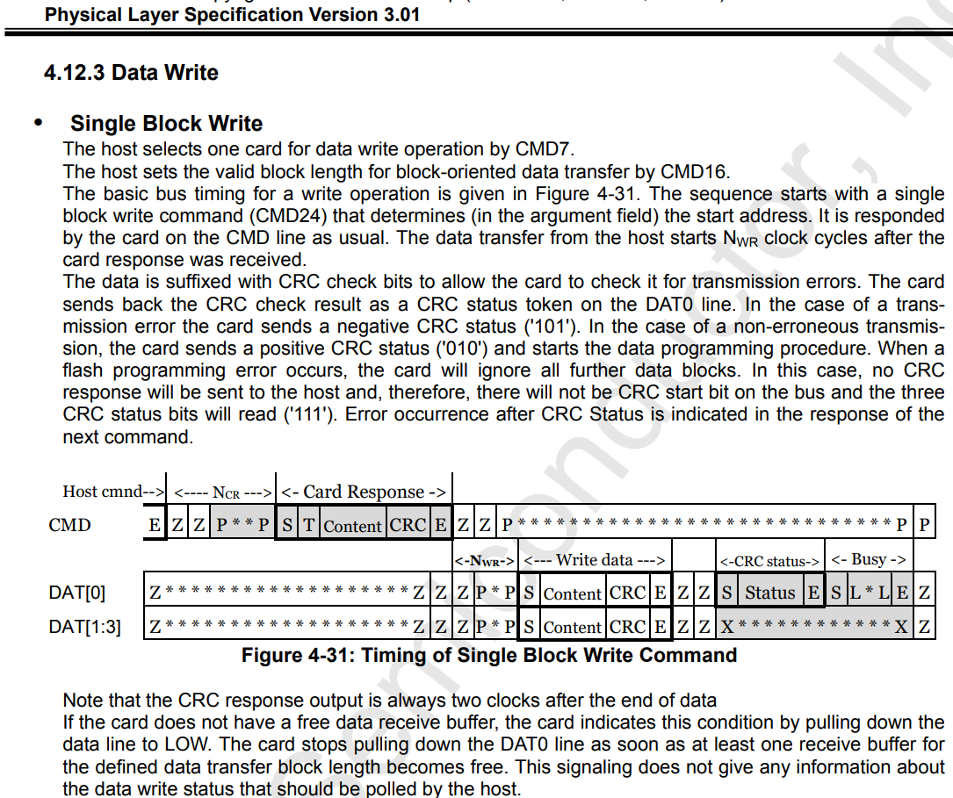

NWR timing specifies a minimum of 2 clocks and no maximum.

## Write Transfer Timings

The *sd_data_serial_host* module uses the following timings are obtained, where data_cycles = 511*8 + 8 = 4096:

|  |  |  |  |
| --- | --- | --- | --- |
| Transfer Cycle | State | Action | Effect |
| 1 | WRITE_DAT | Pull DAT0 LOW | START bit. |
| 2 to 4,097 | WRITE_DAT | Send data bits & set CRC. | SD card receives 512-byte payload as bits, CRC function records data. |
| 4,097 | WRITE_DAT | Set crc_en to 0 | Disables CRC generation/generates CRC. |
| 4,098 to 4,113 | WRITE_DAT | Send 16 CRC bits. | SD card receives CRC to verify data payload. |
| 4,114 | WRITE_DAT | DAT0 HIGH. | Send ‘STOP’ bit to SD card. |
| 4,115 | WRITE_DAT | Disable SD transmission. | End data transmission. Reset SD phy to RD direction. |
| >=4,116 & start_bit (DAT0 LOW) | WRITE_CRC | Read first 3 bits of CRC status. | Reads first 3 LSB of CRC OK byte. Move on to next state once 3 bits read. |
| Don’t care | WRITE_BUSY | Wait for DAT0 to go HIGH. | End of operation. |

Table 1 - SD IP Core Timings

The HDL in SDWriter uses different timing, and initiates the data payload bitstream to the SD card with an index of 0 not 1, so widx = 1 when the first bit of the first byte is sent. data_cycles in SDWriter = 4,096, so this means the SDWriter’s timings differ slightly from those above and look more like the following:

|  |  |  |  |
| --- | --- | --- | --- |
| widx | State | Action | Effect |
| 0 | WRITE_DAT | Pull DAT0 LOW | Signal to SD card start of transfer. |
| 1 to 4,096 | WRITE_DAT | Send data bits. | SD card receives 512-byte payload as bits, CRC function records data. |
| 4,096 | WRITE_DAT | Set crc_en to 0 | Disables CRC generation/generates CRC. |
| 4,097 to 4,112 | WRITE_DAT | Send CRC bits. | SD card receives CRC to verify data payload. |
| 4,113 | WRITE_DAT | DAT0 HIGH. | Send ‘STOP’ bit to SD card. |
| 4,114 | WRITE_DAT | Disable SD transmission. | End data transmission. Reset SD phy to RD direction. |
| >=4,115 & start_bit (DAT0 LOW) | WRITE_CRC | Read first 3 bits of CRC status. | Reads first 3 LSB of CRC OK byte. Move on to next state once 3 bits read. |
| Don’t care | WRITE_BUSY | Wait for DAT0 to go HIGH. | End of operation. |

Table 2 - uCOM SD Interface Timings

It’s clear from the above timing tables that the *sd_data_serial_host* has an additional 8 bits that it sends as part of the payload. I’ve no idea where these bits are sourced from.

I’ve added a stage to the WRITE transaction to check for timeouts whilst waiting for a response from the SD card after sending the payload. The timeout state will send CMD13 to get the Card Status (see pp.115-116 in the Part1_Physical_Layer specs). This indicates that a general error is being caught.

### Issues after INIT optimisation

* ~~WRITE process isn’t starting properly – the first byte, 0xEB, is being written twice.~~
* ~~WRITE process isn’t exiting properly – interface isn’t left in a state where a subsequent READ can be performed. Probably not de-selecting the SD card.~~

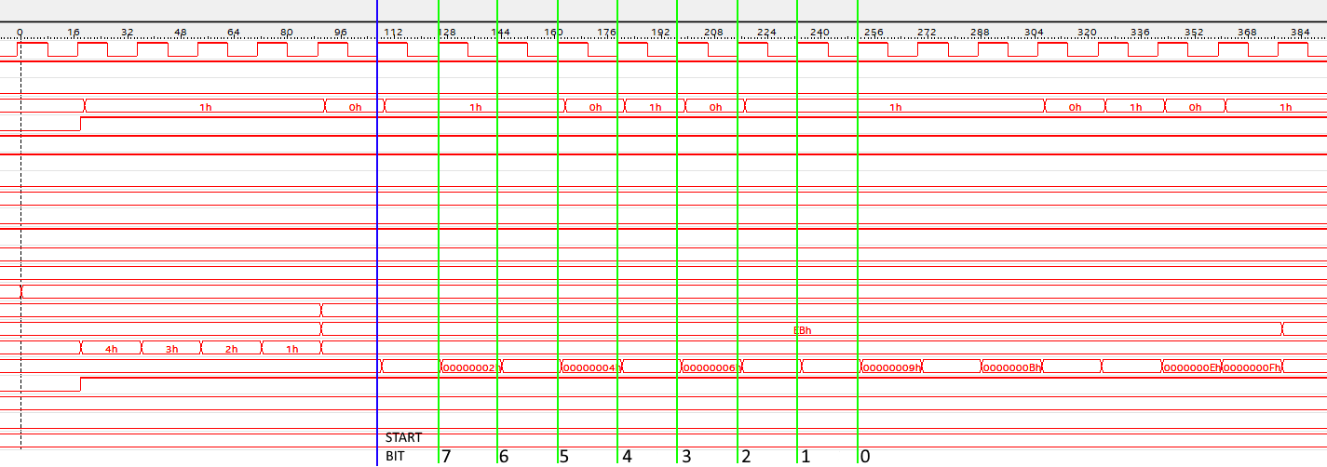

First byte, 0xEB, should end here but instead is being written once more.

Figure 1 - First byte is being written twice.

WRITE process not exiting properly is fixed. I hadn’t finished the HDL in the ENDSEL state, so it wasn’t exiting properly (or de-selecting the card).

Re: WRITE process not starting properly. This appears to be a timing issue, demonstrated in the diagram below, where the byte to written is updated before the byte from the **ByteStreamWriter** is updated due to the new **widx** value.

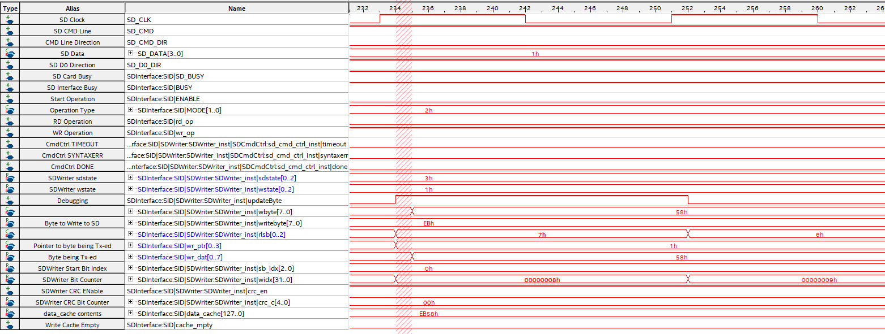

The red shaded area highlights the issue area – where **updateByte** goes HIGH, the value of **wbyte** is placed in **writebyte**. As can be seen, **wbyte** is still 0xEB at this time, as it doesn’t update to the next byte value (0x58) until a clock later.

The fix for this is to delay the **updateByte** section of code by 1 clock.

It’s worth pointing out that this first byte duplication error was first noticed after the INIT optimisation, but may have been present before this.

### Issues after timing fixes

It appears that CRC calculation/transmission is failing. I am not able to compute the correct CRC for 0xFF test block writes or Sector 0 writes. 0xFF blocks should have a CRC of 0x7FA1, and Sector 0 blocks should have a CRC of 0x2713. This is calculated via the CRC checker at <http://www.sunshine2k.de/coding/javascript/crc/crc_js.html>.

I’m confident that the data bytes are being written steadily and with reference to widx, each byte is written starting on widx=0xXX1 and ending on widx=0xXX8 or starting on widx=0xXX9 and ending on widx=0xXX0. The data payload (512 bytes) ends on widx=0x1000. CRC output starts on widx=0x1001 and ends on widx=0x1010. 16 bytes are therefore being written for the CRC, they’re just the wrong bytes!

Changes

1. I’ve rewritten W_START slightly to remove START_BLOCK and just use literal values for lead-in – i.e., sddat[0] is HIGH by default and is pulled LOW only when sd_idx = 1. This should have no material effect on the operation of the WRITE process.
2. I’ve rewritten the WRITE HDL to make sddat a register instead of a wire.
3. HDL rewrite includes treating sddat as a 4-bit array instead of just a single-bit line. This means the HDL is much closer to the example code used and will be easier to port to 4-bit mode.

## Big Problem Fixed

As a result of making the above changes, CRC calculations are still out and require further work, but most importantly I’ve identified why I’m getting nothing back from the SD card. It’s because sddat is an OUTPUT only – so changing SD_DO_DIR will do nothing; no input will be received no matter how hard I try! The solution is to create a 4-bit input to SDWriter to take the SD_DATA as an input, and read that instead of sddat when a read is required. So sddat is now sddat_o and the new input is sddat_i.

This seems to have fixed the lack of response from the SD card – I am now getting a response! It appears to be 101, where it should be 010, but this is likely due to a rejected CRC value. Onwards and upwards!

One thing I’ve noticed is the crc_rst seems to be high all the way through. This would be a clear problem. Initial testing is throwing up some weird results – crc_rst seems to be inverted from the values set in the SDWriter module. This required some investigation and messing around (seemingly randomly) with assigning values to crc_rst. In the end, it fixed itself and didn’t affect the CRC values being output, so I’m not sure it was an issue to start with; might have been a SignalTap glitch or something.

### CRC Problem Identified

After a little testing, it is clear that the CRC value being written to the SD card is delayed by 1 clock. I’m not sure where the value being written at 0x1001 is coming from, but the CRC isn’t getting written until 0x1002.

Moving the write of the first bit of the CRC into the end of W_DAT fixes the issue, and also fixes the WRITE module – it’s now working!!